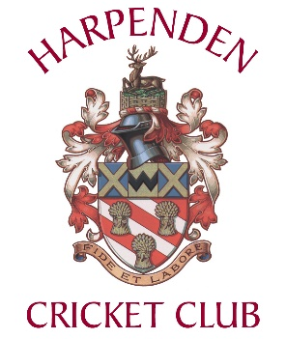
Harpenden CC - Code of Conduct 2023
All Members of HCC agree to abide by this Code of Conduct

All Members and Guests of Harpenden Cricket Club will:
- treat everyone equally and not discriminate on the grounds of age, gender, disability, race, ethnic origin, nationality, colour, parental or marital status, religious belief, class or social background, sexual orientation, or political belief
- not condone, or allow to go unchallenged, any form of discrimination if witnessed
- not condone, or allow to go unchallenged, any form of bullying
- display high standards of behaviour
- promote the positive aspects of Cricket e.g., fair play
- encourage all participants to learn the Laws and rules and play within them, respecting the decisions of match officials
- actively discourage unfair play, rule violations and arguing with match officials.
At Harpenden Cricket Club we will follow the ECB Code of conduct and Spirit of Cricket regulations governing players conduct on the field of play.
Specifically, any club player or official will:
- conduct themselves properly and fairly on and off the field of play
- not engage in verbal or physical abuse or hostility to other players or members of the public
- not engage in crude, abusive, or personal sledging of other players or officials nor use abusive gestures
- not engage in excessive and/or intimidatory appealing
- welcome and respect players and guests to Harpenden Cricket Club.
Any player reported, cited by the umpires or by his own captain for breach of this Code of Conduct will be requested to appear before the club's disciplinary committee as soon as possible.
If a breach of the Code is established the disciplinary committee shall have the right to impose penalties.
In addition to the above, all club officers and appointed volunteers will:
- hold relevant qualifications and be covered by appropriate insurance
- know and understand the ECB’s “Safe Hands – Cricket’s Policy for Safeguarding Children”
- develop an appropriate working relationship with Young Players, based on mutual trust and respect
- attend appropriate training to keep up to date with their role and especially with respect to the Safeguarding of young People.
Illegal or Banned Substances
HCC has a zero-tolerance policy on drugs and banned substances in and around the pavilion and whilst on club facilities.
Anyone who is found in possession of a banned substance, or is witnessed consuming a banned substance, will be subject to disciplinary action.
Members are reminded that any instances should be reported to a member of the Committee, and that they are also responsible for the actions of their guests, when present at the Club.
Grievance and Help
The club operates a confidential helpline where members can contact our welfare officer in confidence to highlight any issues or concerns. This can be used if any member believes they have cause to raise a grievance. The email address is confidential@harpendencc.co.uk
A Family Club
The Committee at Harpenden CC value the fact that we are a family club which promotes:
- the playing of cricket at all levels
- the correct conduct of its members on and off the pitch through our Club Mark status
- our own Code of Conduct.

Adopted by HCC Exec Committee and effective 3rd August 2022

